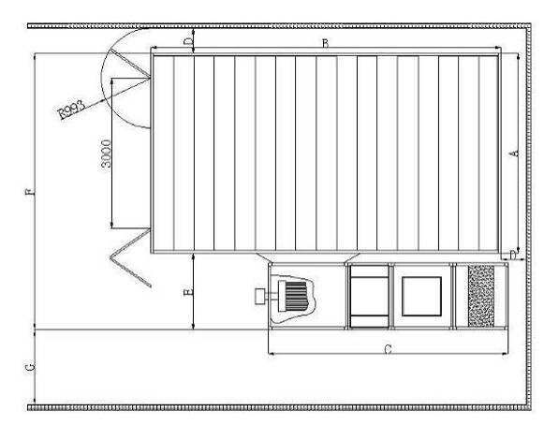
Fig. 2.1

DIM.INT.(mm) | A | B | C | D | E | F | G
6900x3900x2700 | 4000 | 7000 | 3155 | 500 | 1255 | 5300 | 1200

